2.

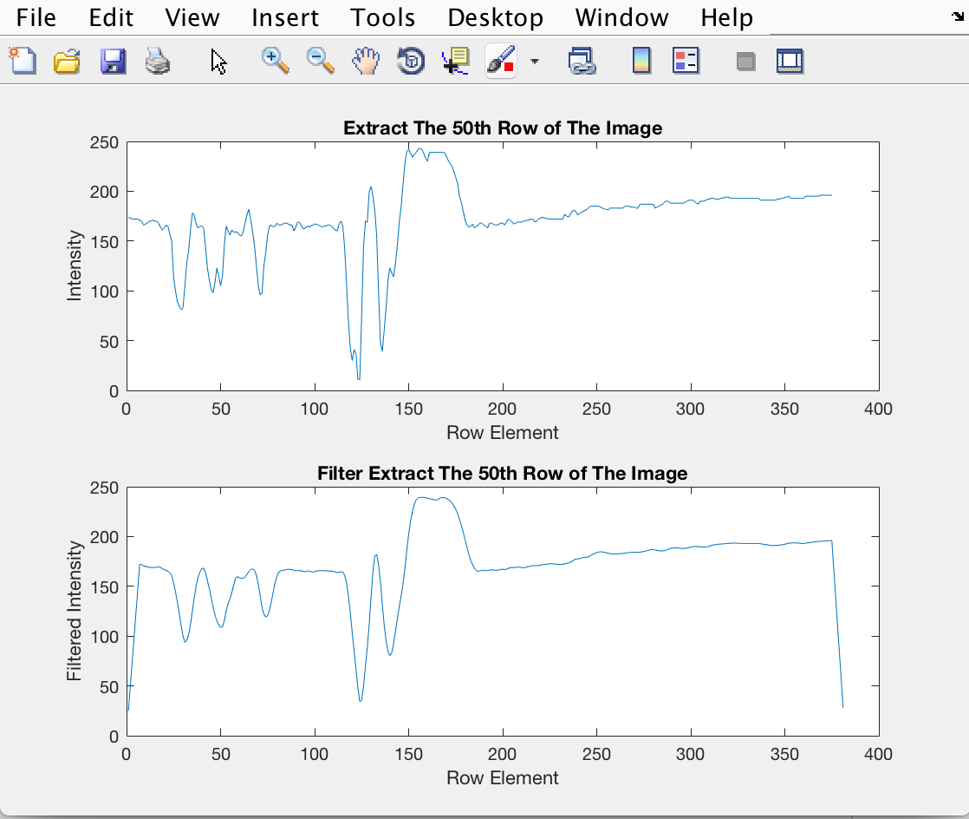

For 100th column:

clear all;

close all;

clc;

load('ip2_images');

column = cicada(100,:); %Extracts 100th row

ave_filt = ones(1,7)/7; %Calculate filter coefficients

filt_column = conv(column,ave_filt); %Filter 100th column

subplot(2,1,1); % plot the unfiltered signals

plot(column),

title('Extract The 100th column of The Image'),

xlabel('Column Element'),

ylabel('Intensity'),

subplot(2,1,2); %plot the filtered signals

plot(filt_column),

title('Filter Extract The 100th column of The Image')

xlabel('Column Element'),

ylabel('Filtered Intensity'),

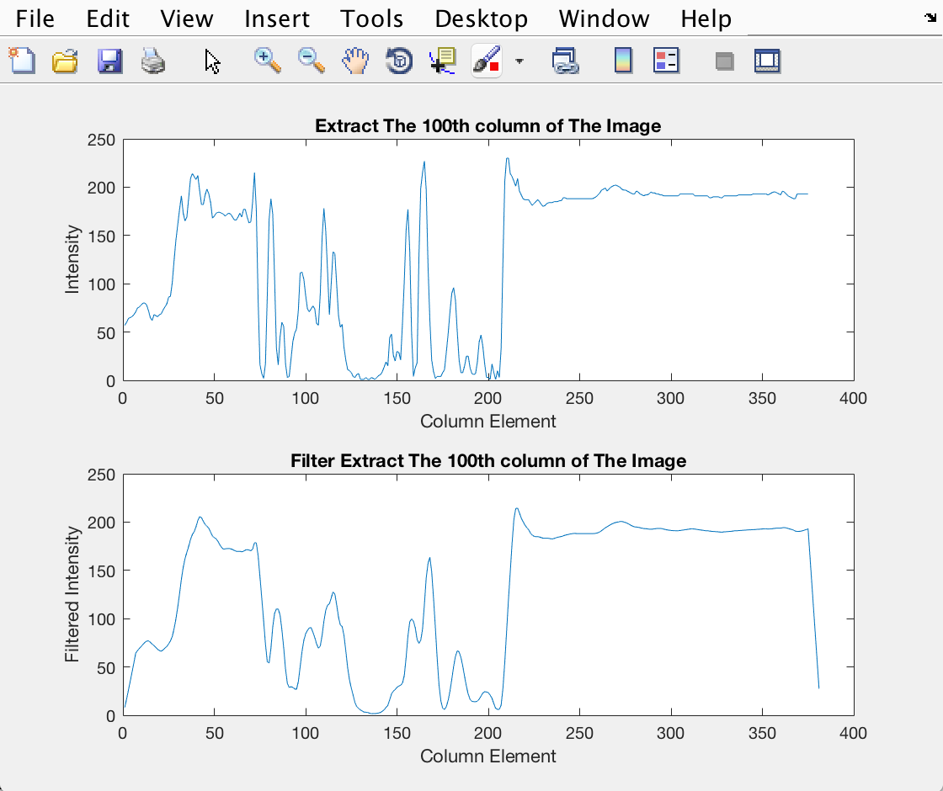

The filtered output is smoother than the input.

2.1

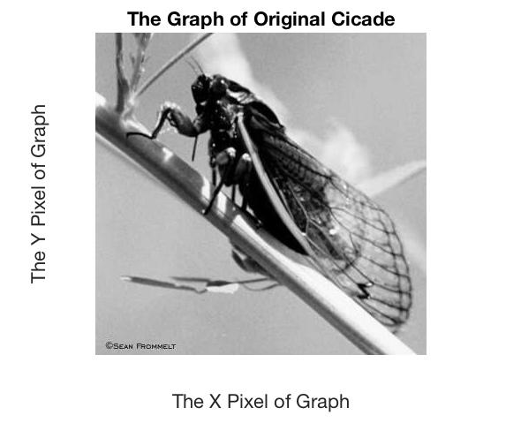

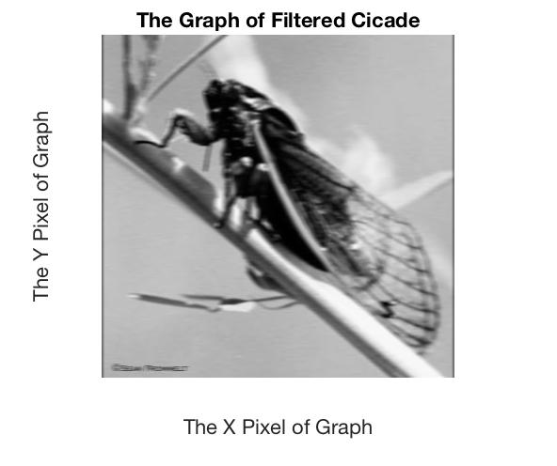

The filtered image looks like a blurred cicade’s image. The quality of the image is not very clear, and is blurred throughout the image.

Filtering row only:



Filtering row and column:



Both the filtered images look’s the same blurry.

For column filtering following modification in Matlab code was used:

function y_column = filtcolumn(image,filt)

[row,column] = size(image);

for y = 1 : column

    y_column(:,y) = conv(image(:,y),filt);

    y_column(:,y) = round(y_column(:,y));

end

length_filt = length(filt); %find filter half-length

half_len = floor(length_filt/2);

y_column = y_column(row+half_len:half_len+1,:); %extract the c pixels in the center of the columns

For 3 point averaging filter:

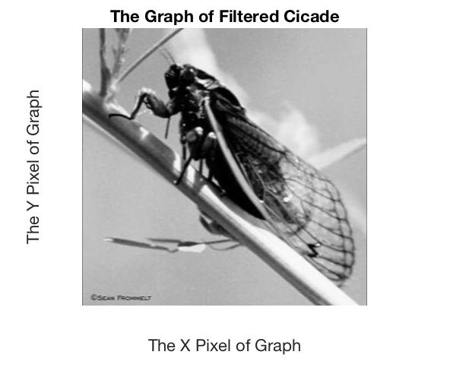



For 7 point averaging filter:





For [1 2 4 2 1]/10 :

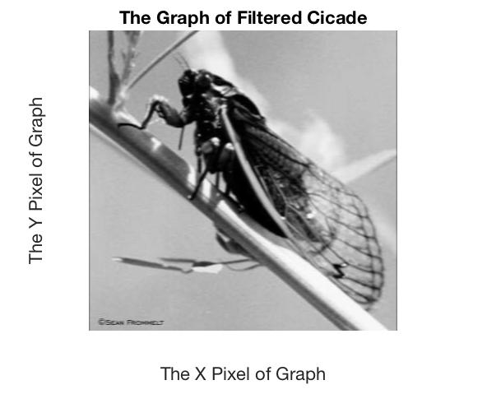



Since from the above images all the filtered images are blurred. Hence, all the above are low-pass filter.

A low pass filter is a filter which blurs the pixels of the image, while a high-pass filter intensifies it.

2.2

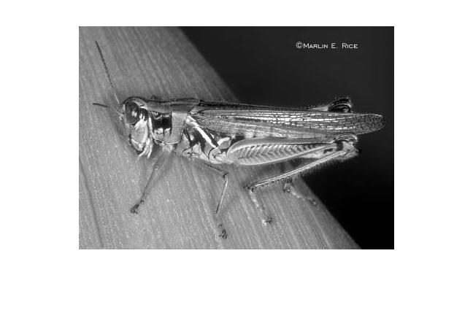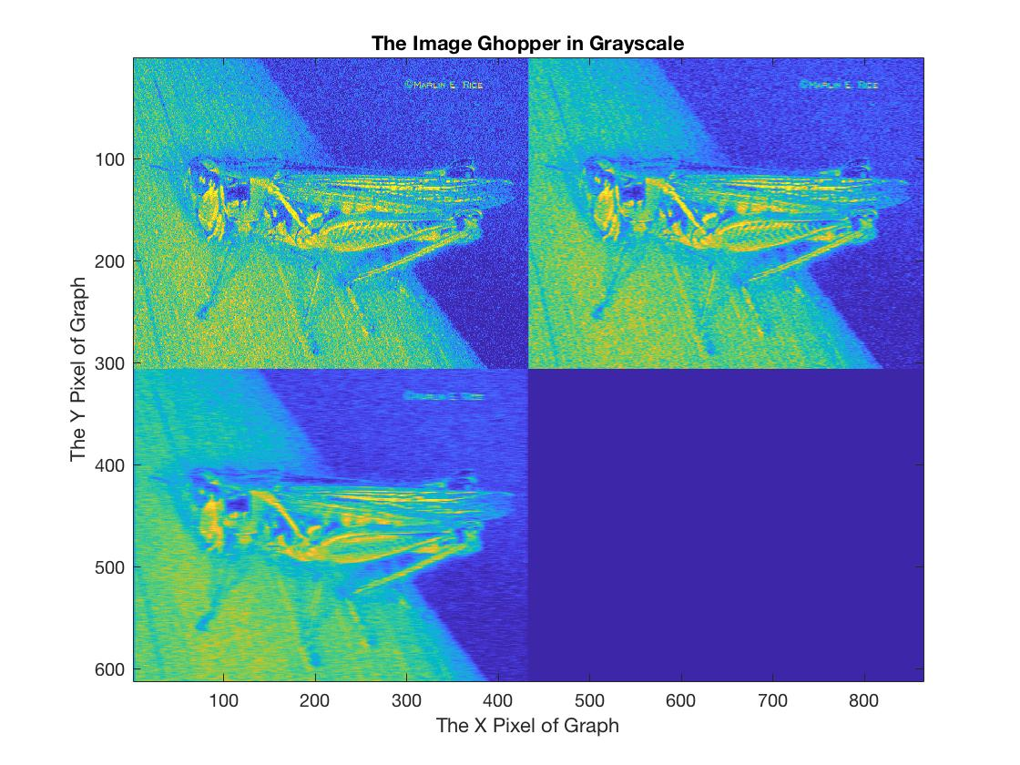

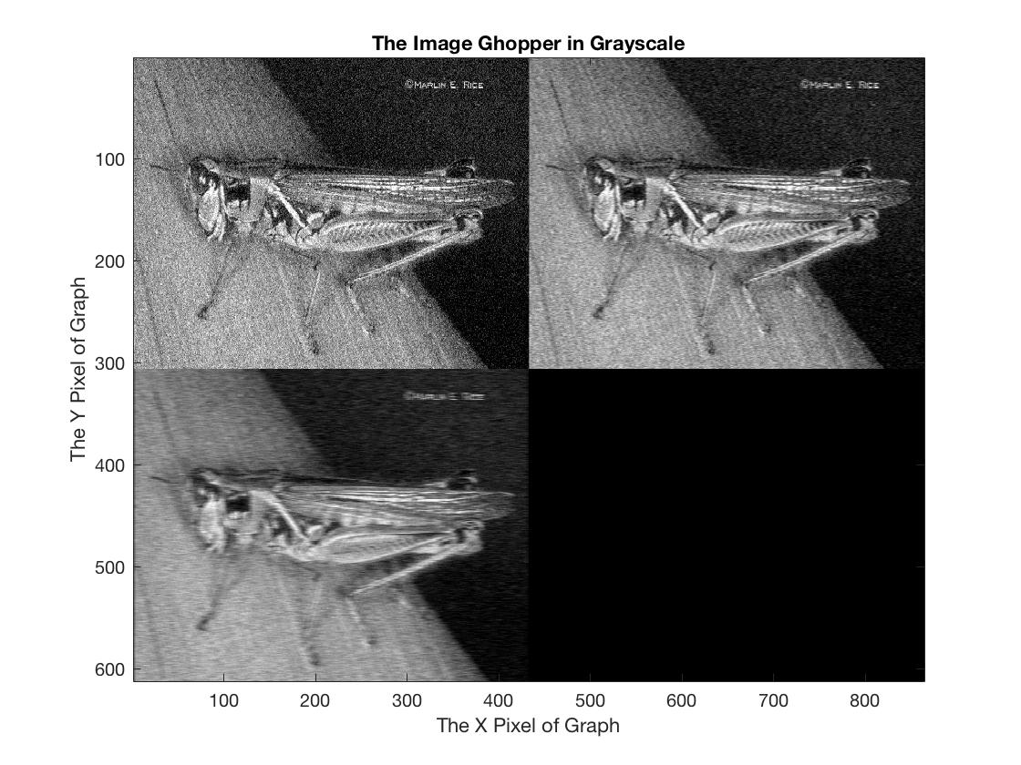

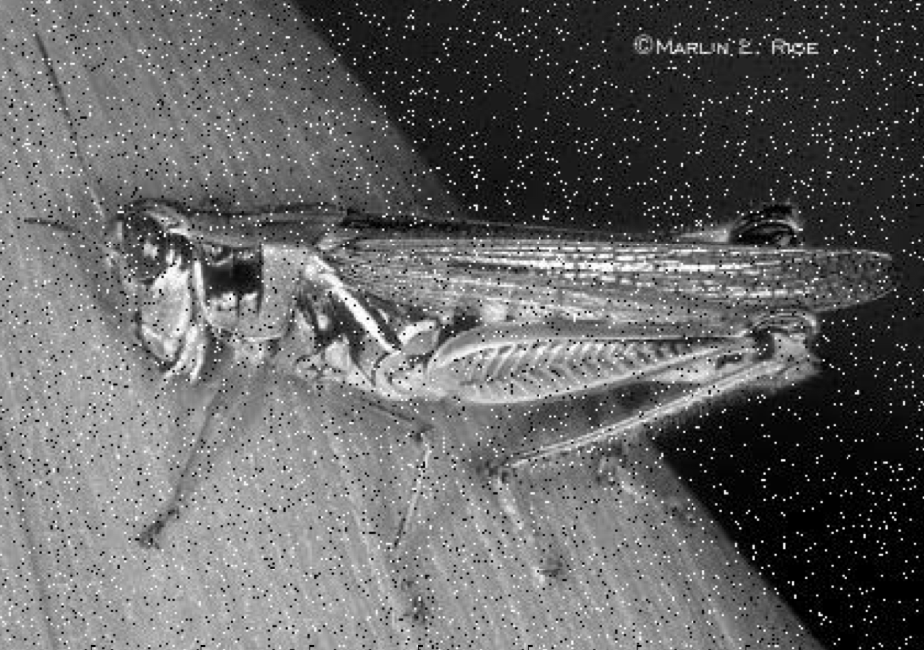

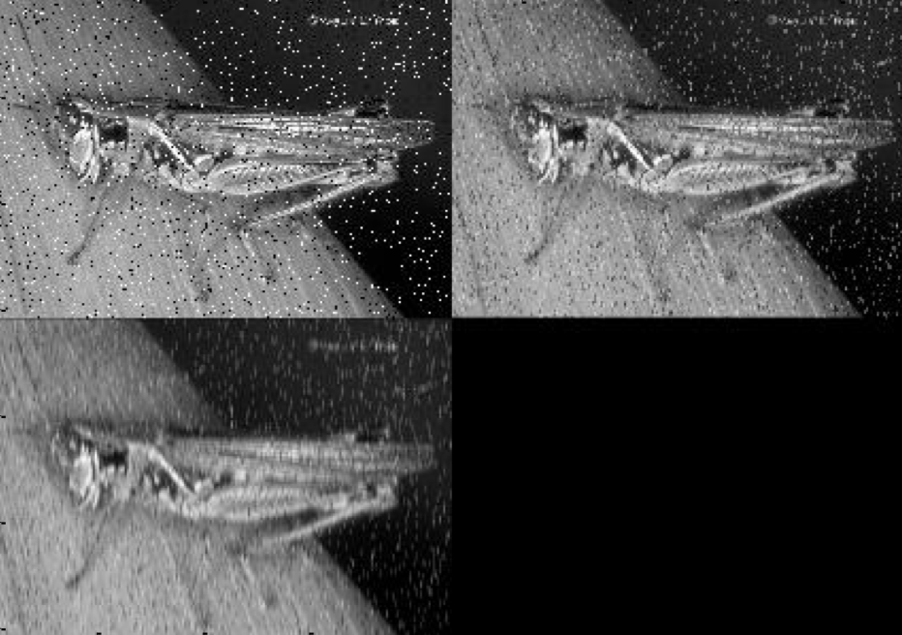

Well from the above images, I feel that filtering worked same for all the type of noises.

2.3

For image using filter (a):

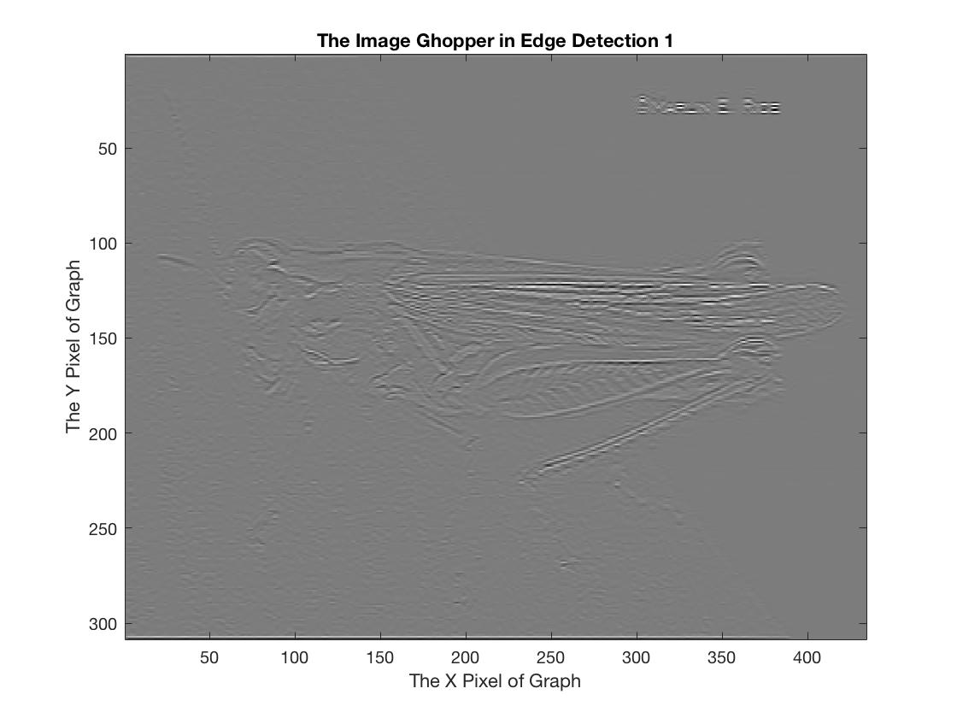

The horizontal edges were highlighted in this case.

For image using filter (c):

The following Matlab code was used:

clear all;

close all;

clc;

load('ip2_images');

wc = [-1,2,-1;-1,2,-1;-1,2,-1]; % filter (c)

y_c=conv2(ghopper,wc);

y_c=round(y_c);

imagesc(y_c);

colormap('gray(256)');

title('Extra credit Edge Detection'),

xlabel('The X Pixel of Graph'),

ylabel('The Y Pixel of Graph'),

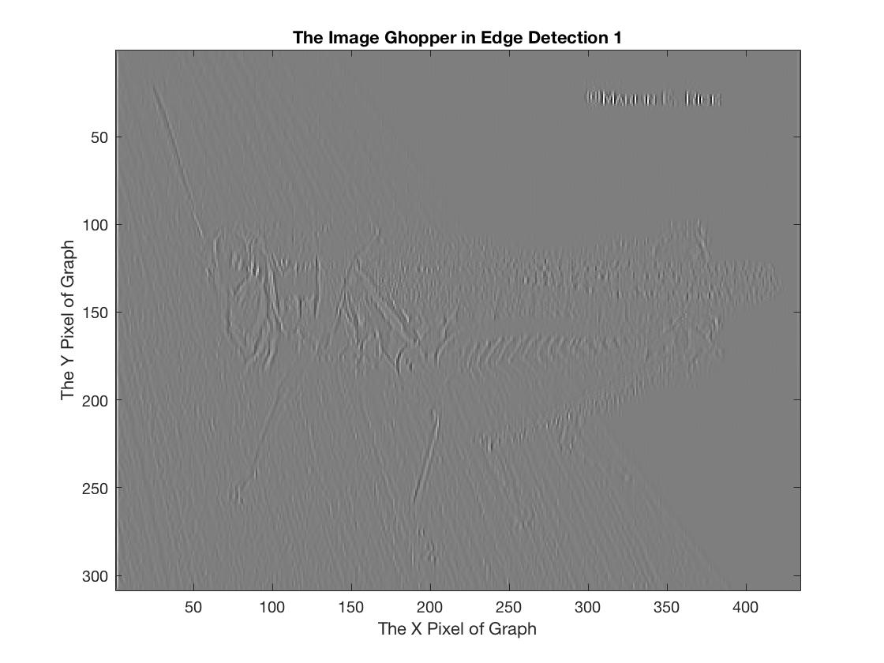

The vertical edges were highlighted in this case.

Comparing the above images, (a) has horizontal edges, while (c) has vertical edges.

Extra Credit:

